Mathematical Methods

1a i)

We only care about the tail of [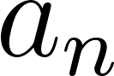](http://www.codecogs.com/eqnedit.php?latex=a_n) so we will only discuss the case where [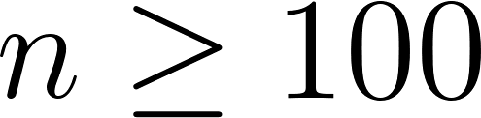](http://www.codecogs.com/eqnedit.php?latex=n%20%5Cgeq%20100).

[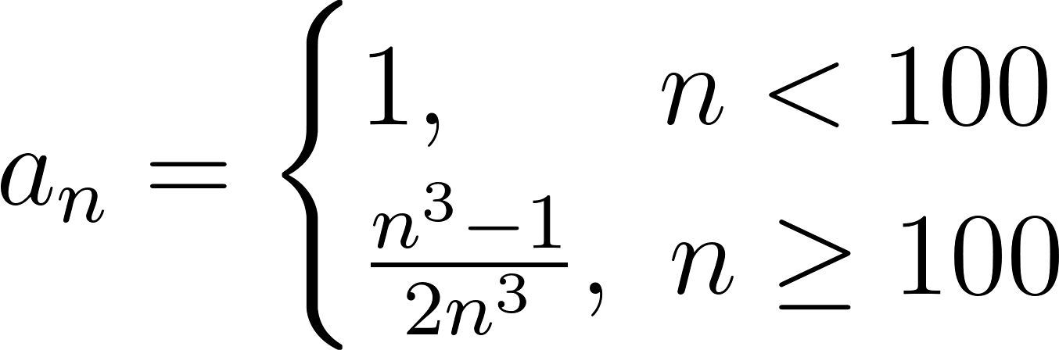](http://www.codecogs.com/eqnedit.php?latex=%20%20%20a_n%20=%20%5Cbegin%7Bcases%7D%201,%5C%20%5C%20%5C%20%5C%20%5C%20n%20%3C%20100%20%5C%5C%20%5Cfrac%7Bn%20%5E%203%20-%201%7D%20%7B2%20n%20%5E%203%7D,%5C%20n%20%5Cgeq%20100%20%5Cend%7Bcases%7D%20%20%20)

[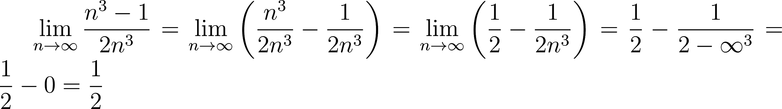](http://www.codecogs.com/eqnedit.php?latex=%5Clim_%7Bn%5Cto%5Cinfty%7D%20%20%5Cfrac%7Bn%20%5E%203%20-%201%7D%20%7B2%20n%20%5E%203%7D%20%20=%20%5Clim_%7Bn%5Cto%5Cinfty%7D%20%5Cleft(%5Cfrac%7Bn%20%5E%203%7D%20%7B2%20n%20%5E%203%7D%20-%20%5Cfrac%7B1%7D%7B2n%5E3%7D%5Cright)%20=%20%5Clim_%7Bn%5Cto%5Cinfty%7D%20%5Cleft(%5Cfrac%7B1%7D%7B2%7D%20-%20%5Cfrac%7B1%7D%7B2n%5E3%7D%5Cright)%20=%20%5Cfrac%7B1%7D%7B2%7D%20-%20%5Cfrac%7B1%7D%7B2%20-%20%5Cinfty%20%5E%203%7D%20=%20%5Cfrac%7B1%7D%7B2%7D%20-%200%20=%20%5Cfrac%7B1%7D%7B2%7D)

So[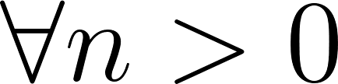](http://www.codecogs.com/eqnedit.php?latex=%5Cforall%20n%20%3E%200) converges Says to use the formal definition of convergence, so can’t use this method.

BTEC Computing solution:

Recall the formal definition of the limit:

$∀ϵ>0.∃N∈\backslash N.n>N s.t |a_{n}-l| < ϵ$

We guess a limit l = 0.

$|\frac{n^{3}-1}{2n^{3}}-1|<ϵ$

….. (i hate google docs equations)

$n >^{3}\sqrt{\frac{1}{2ϵ-1}}$

So we have $N(ϵ) = \backslash ceil\{....\}$

Hence converges.

ii)

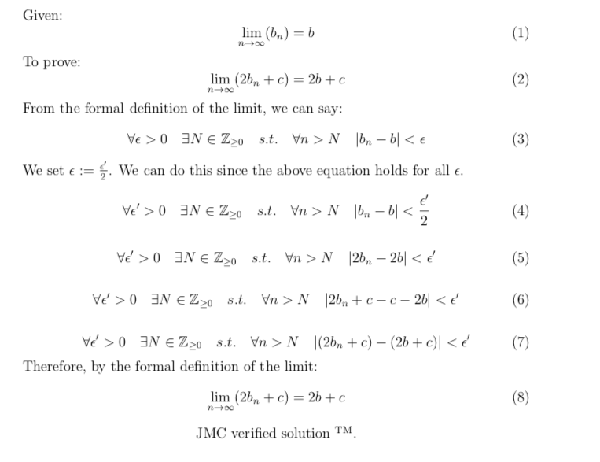

b .

[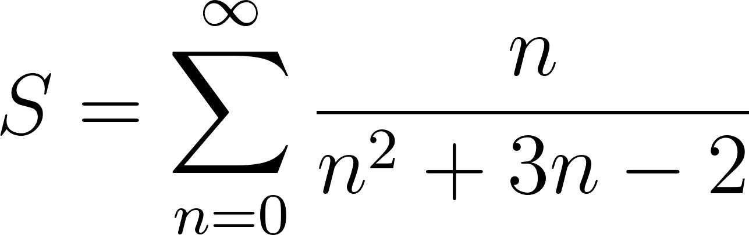](http://www.codecogs.com/eqnedit.php?latex=%20S%20=%20%5Csum_%7Bn%20=%200%7D%5E%7B%5Cinfty%7D%20%5Cfrac%7Bn%7D%7Bn%5E2&plus;3n-2%7D)

Limit comparison test: If exists [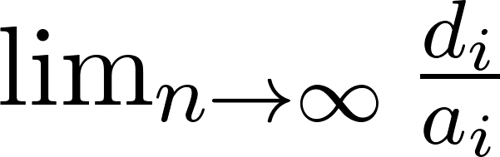](http://www.codecogs.com/eqnedit.php?latex=%5Clim_%7Bn%5Cto%5Cinfty%7D%20%5Cfrac%7Bd_i%7D%7Ba_i%7D%20)and finite then [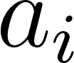](http://www.codecogs.com/eqnedit.php?latex=a_i) is divergent, where [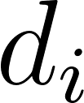](http://www.codecogs.com/eqnedit.php?latex=d_i) is a divergent sequence.

[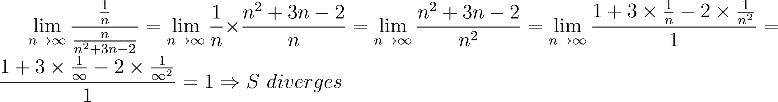](http://www.codecogs.com/eqnedit.php?latex=%20%5Clim_%7Bn%5Cto%5Cinfty%7D%20%5Cfrac%7B%5Cfrac%7B1%7D%7Bn%7D%7D%7B%5Cfrac%7Bn%7D%7Bn%5E2%20&plus;%203n%20-%202%7D%7D%20=%20%5Clim_%7Bn%5Cto%5Cinfty%7D%20%5Cfrac%7B1%7D%7Bn%7D%20%5Ctimes%20%5Cfrac%7Bn%5E2&plus;3n-2%7D%7Bn%7D%20=%20%5Clim_%7Bn%5Cto%5Cinfty%7D%20%5Cfrac%7Bn%5E2%20&plus;%203n%20-%202%7D%7Bn%5E2%7D%20=%5Clim_%7Bn%5Cto%5Cinfty%7D%20%5Cfrac%7B1%20&plus;%203%20%5Ctimes%20%5Cfrac%7B1%7D%7Bn%7D%20-%202%20%5Ctimes%20%5Cfrac%7B1%7D%7Bn%5E2%7D%7D%7B1%7D%20=%20%5Cfrac%7B1%20&plus;%203%20%5Ctimes%20%5Cfrac%7B1%7D%7B%5Cinfty%7D%20-%202%20%5Ctimes%20%5Cfrac%7B1%7D%7B%5Cinfty%5E2%7D%7D%20%7B1%7D%20=%201%20%5CRightarrow%20S%20%5C%20diverges)

C

D’Alembert limit ratio test -> Sn converges for 1/(x-2)<1 ⇔ x<1 or x>3.

2c i) General solution: λ[-1, -1, 0] for λ ϵ ℝ

This is just the same as λ[1, 1, 0] for λ ϵ ℝ, except I just took -1 out. However, I’m interested in how you would get to this -1 -1 result? Please do elaborate.

ii) rk(M) = 2 as there are 2 linearly independent vectors.

Alternatively, from (i) the nullity is 1, and the number of columns of M is 3. By the rank-nullity theorem, rk(M) = 3 – 1 = 2

iii) λ = -6, 0, 3